

**Public Library Resources**

<https://www.ohioweblibrary.org/sources>

OPLIN



Amherst

Avon Lake

Grafton

Oberlin  
Wellington

**Cuyahoga County**

**Cuyahoga County System Cleveland Public Library System**

**Lakewood Westlake/Porter E. Cleveland**   
  
 3 independent libraries who are part of CLEVNET:   
 Euclid Shaker Cleveland Heights **Rocky River**

**Lorain Public Library System**

Main & South

Avon

Columbia Branch

Domonkas/Sheffield Lake

N. Ridgeville

CLEVNET

**Elyria Public library System**

Central/Washington Ave

West River

North (LCCC)

South (Middle Ave)

Keystone/LaGrange

Bookmobile

<https://www.clevnet.org/node/8>

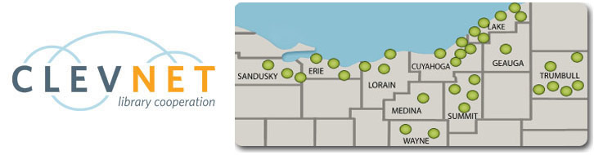

Lorain County Libraries

Vermilion/Ritter

**Ohio Find-a-Library**[**http://tinyurl.com/7c5e3rs**](http://tinyurl.com/7c5e3rs)

Lorain System  
Elyria System  
Vermilion/Ritter

CLEVNET -🡪

🡨 NOT CLEVNET

Amherst  
Avon Lake  
Grafton  
Oberlin  
Wellington

**Locally Purchases Resources**

[Type a quote from the document or the summary of an interesting point. You can position the text box anywhere in the document. Use the Drawing Tools tab to change the formatting of the pull quote text box.]